Comparative analysis

2024-08-17

## Load Required Libraries  
library(tidyverse)

## ── Attaching core tidyverse packages ──────────────────────── tidyverse 2.0.0 ──  
## ✔ dplyr 1.1.4 ✔ readr 2.1.5  
## ✔ forcats 1.0.0 ✔ stringr 1.5.1  
## ✔ ggplot2 3.5.1 ✔ tibble 3.2.1  
## ✔ lubridate 1.9.3 ✔ tidyr 1.3.1  
## ✔ purrr 1.0.2   
## ── Conflicts ────────────────────────────────────────── tidyverse_conflicts() ──  
## ✖ dplyr::filter() masks stats::filter()  
## ✖ dplyr::lag() masks stats::lag()  
## ℹ Use the conflicted package (<http://conflicted.r-lib.org/>) to force all conflicts to become errors

library(lme4)

## Loading required package: Matrix  
##   
## Attaching package: 'Matrix'  
##   
## The following objects are masked from 'package:tidyr':  
##   
## expand, pack, unpack

library(readxl)  
library(janitor)

##   
## Attaching package: 'janitor'  
##   
## The following objects are masked from 'package:stats':  
##   
## chisq.test, fisher.test

library(RColorBrewer)

## Load the Data  
# Read in the data from the working directory  
df <- read_excel("africa_data.xlsx")  
  
  
df <- clean_names(df)  
df <- df %>% filter(!is.na(status))  
df$in_out_patient <- df$in_out_patient %>% replace(is.na(.), "None Given")   
  
### Converting to Factor  
  
df <- df %>%  
 mutate(  
 country = as.factor(country),  
 speciality = as.factor(speciality),  
 source = as.factor(source),  
 status = as.factor(status),  
 year = as.numeric(year),  
 concentration = as.numeric(concentration),  
 age_group = as.factor(age_group),  
 species = as.factor(species),  
 gender = as.factor(gender),  
 in_out_patient = as.factor(in_out_patient),  
 antibiotics = as.factor(antibiotics)  
 )  
  
## Summary of the Data  
  
summary(df)

## isolate_id study species   
## Min. :3.535e+04 Length:330100 Escherichia coli : 62267   
## 1st Qu.:1.102e+06 Class :character Klebsiella pneumoniae : 59360   
## Median :1.905e+06 Mode :character Staphylococcus aureus : 43103   
## Mean :2.538e+08 Pseudomonas aeruginosa : 31965   
## 3rd Qu.:2.348e+06 Enterobacter cloacae : 15753   
## Max. :2.305e+09 Acinetobacter baumannii: 14158   
## (Other) :103494   
## family country state gender   
## Length:330100 South Africa:170202 Mode:logical Female:156500   
## Class :character Nigeria : 58559 NA's:330100 Male :169961   
## Mode :character Morocco : 57153 NA's : 3639   
## Cameroon : 10343   
## Kenya : 9546   
## Ivory Coast : 8342   
## (Other) : 15955   
## age_group speciality   
## 0 to 2 Years : 38013 Medicine General :126311   
## 13 to 18 Years: 10170 Surgery General : 53337   
## 19 to 64 Years:174140 Pediatric General : 33044   
## 3 to 12 Years : 22777 Medicine ICU : 26151   
## 65 to 84 Years: 62255 General Unspecified ICU: 19955   
## 85 and Over : 8340 None Given : 17250   
## Unknown : 14405 (Other) : 54052   
## source in_out_patient year   
## Blood :60824 Inpatient :104057 Min. :2004   
## Urine :55536 None Given:218632 1st Qu.:2014   
## Wound :54816 Other : 895 Median :2019   
## Sputum :37062 Outpatient: 6516 Mean :2017   
## Abscess :14585 3rd Qu.:2021   
## Endotracheal aspirate:12087 Max. :2022   
## (Other) :95190   
## phenotype antibiotics status   
## Length:330100 Levofloxacin : 25018 Intermediate: 25077   
## Class :character Tigecycline : 20156 Resistant : 78311   
## Mode :character Meropenem : 17823 Susceptible :226712   
## Piperacillin tazobactam: 16668   
## Cefepime : 16441   
## Amikacin : 16074   
## (Other) :217920   
## concentration   
## Min. : 0.002   
## 1st Qu.: 0.250   
## Median : 1.000   
## Mean : 7.508   
## 3rd Qu.: 4.000   
## Max. :128.000   
##

## Visualizing the Data

### Distrubution of status across countries

ggplot(df, aes(x = country, fill = status)) +  
 geom_bar(position = "fill") +  
 labs(title = "Proportion of Resistance Status by Country", x = "Country", y = "Proportion") +  
 scale_fill_manual(values =c("Intermediate"="skyblue","Resistant"="red","Susceptible"="green"))+  
 theme_bw() +  
 coord_flip()

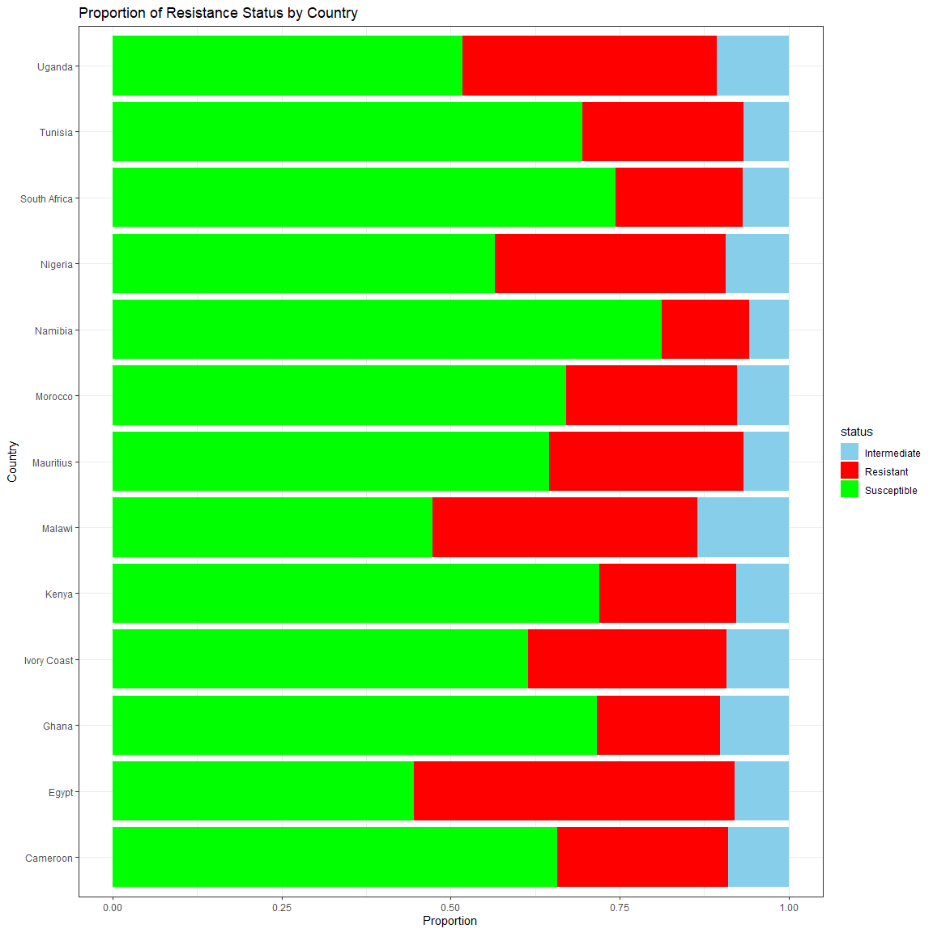

ggplot(df, aes(x = antibiotics, fill = status)) +  
 geom_bar(position = "fill") +  
 facet_grid( ~ country, scales = "free") +  
 labs(title = "Panel of Resistance by Country", x = "Country", y = "Proportion") +  
 scale_fill_manual(values =c("Intermediate"="skyblue","Resistant"="red","Susceptible"="green")) +  
 theme_bw() +  
 coord_flip()

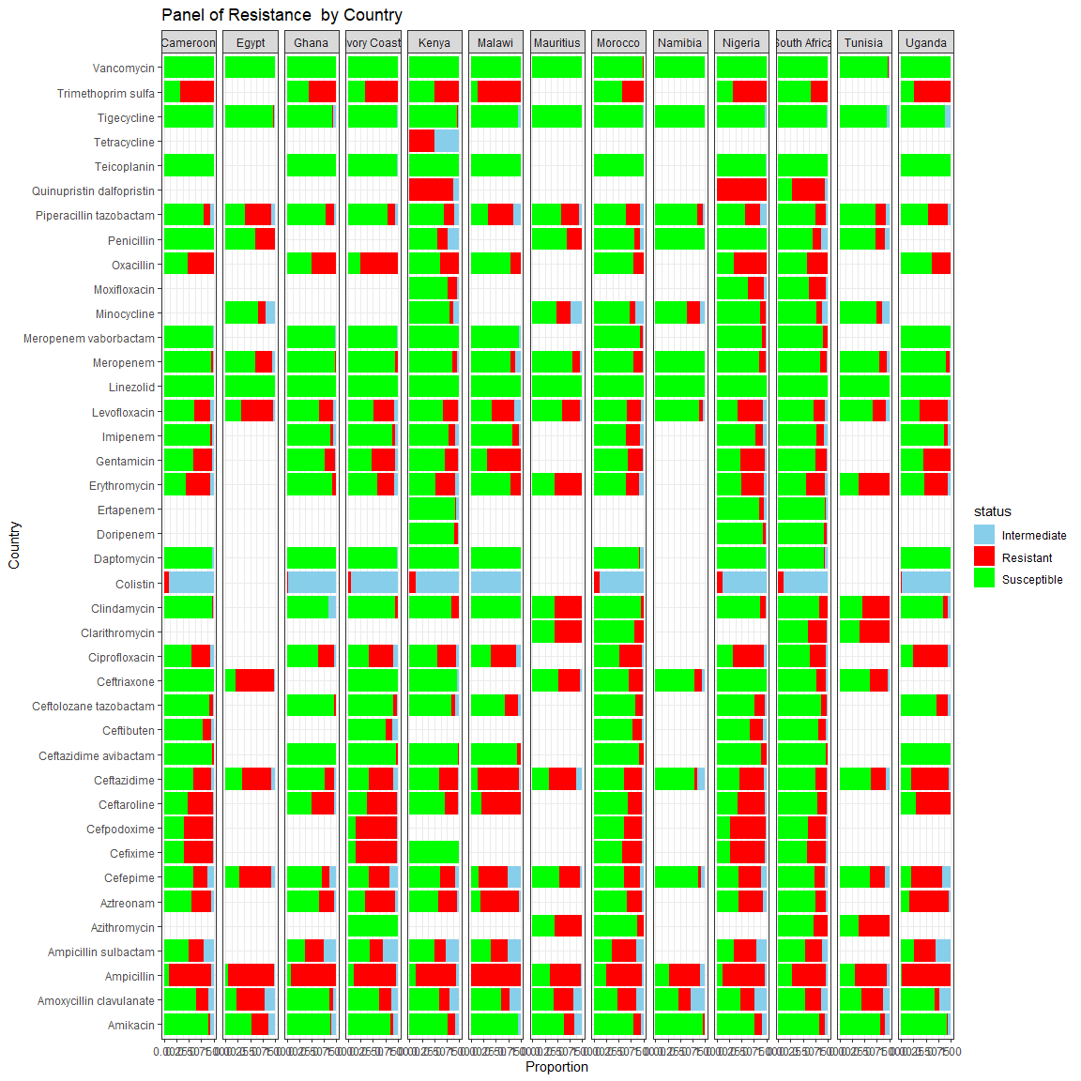

ggplot(df, aes(x = speciality, fill = status)) +  
 geom_bar(position = "fill") +  
 labs(title = "Proportion of Resistance Status by Speciality", x = "Speciality", y = "Proportion") +  
 scale_fill_manual(values =c("Intermediate"="skyblue","Resistant"="red","Susceptible"="green")) +  
 theme_bw() +  
 coord_flip()

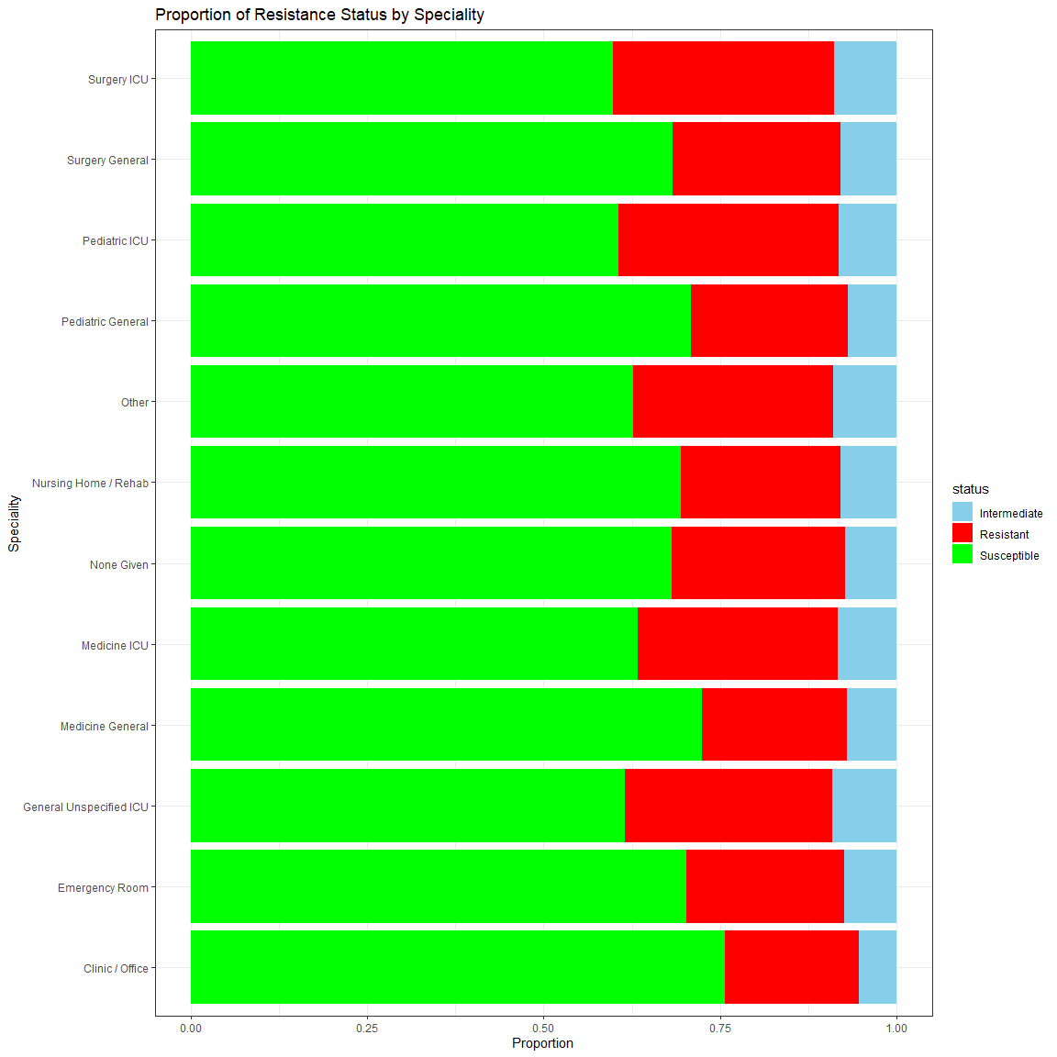

ggplot(df, aes(x = speciality, fill = status)) +  
 geom_bar(position = "fill") +  
 facet_grid( ~ country, scales = "free") +  
 labs(title = "Panel of Resistance Status by Speciality", x = "Speciality", y = "Proportion") +  
 scale_fill_manual(values =c("Intermediate"="skyblue","Resistant"="red","Susceptible"="green")) +  
 theme_bw() +  
 theme(axis.text.x = element_blank()) +  
 coord_flip()

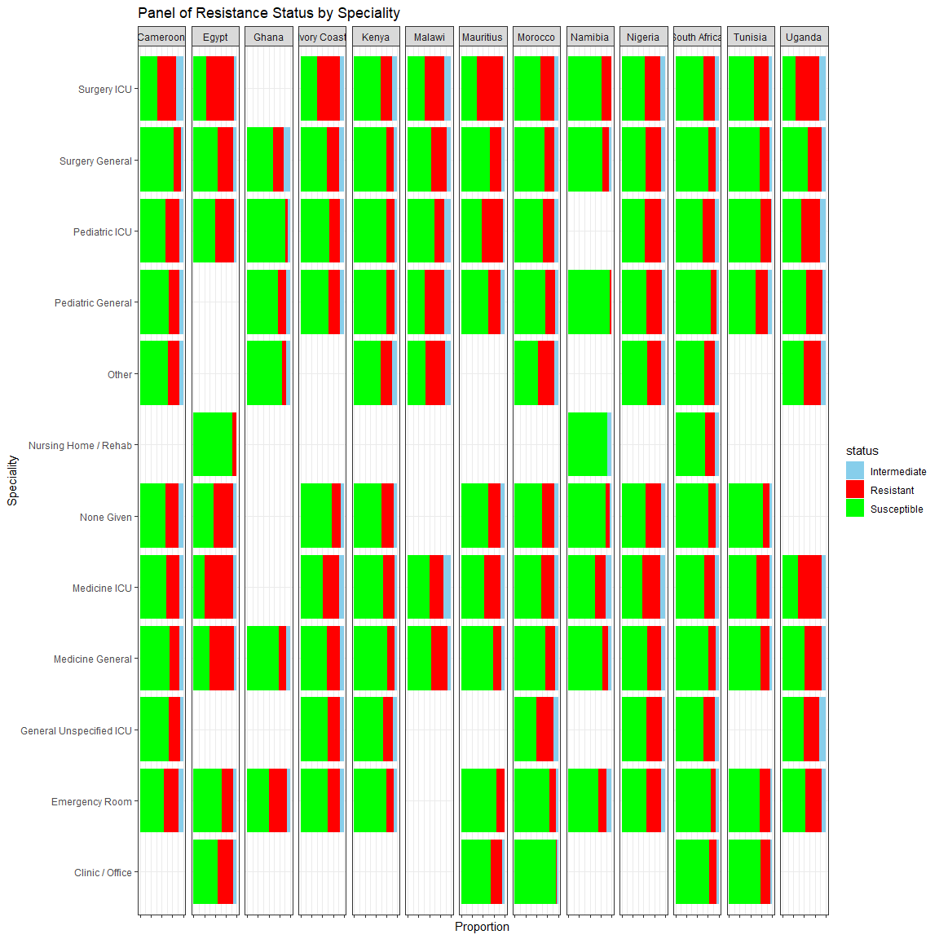

ggplot(df, aes(x = source, fill = status)) +  
 geom_bar(position = "fill") +  
 labs(title = "Proportion of Resistance Status by Isolation Source", x = "Isolation Soruce", y = "Proportion") +  
 scale_fill_manual(values =c("Intermediate"="skyblue","Resistant"="red","Susceptible"="green")) +  
 theme_bw( ) +  
 coord_flip()

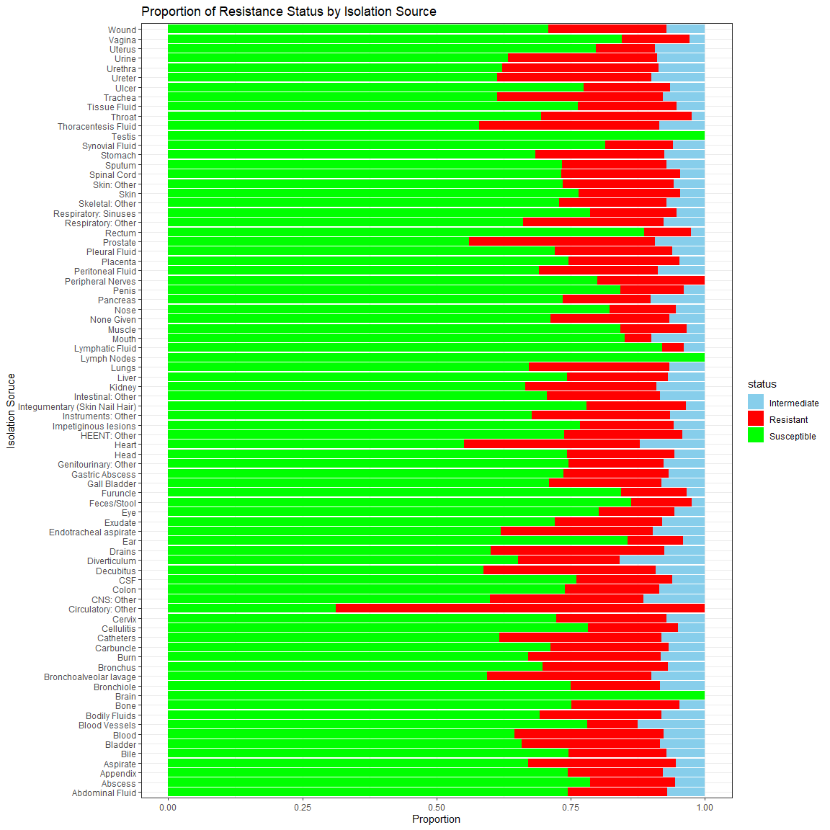

ggplot(df, aes(x = source, fill = status)) +  
 geom_bar(position = "fill") +  
 facet_grid( ~ country, scales = "free") +  
 labs(title = "Panel of Resistance Status by Isolation Source", x = "Isolation Source", y = "Proportion") +  
 scale_fill_manual(values =c("Intermediate"="skyblue","Resistant"="red","Susceptible"="green")) +  
 theme_bw( ) +  
 theme(axis.text.x = element_blank()) +  
 coord_flip()

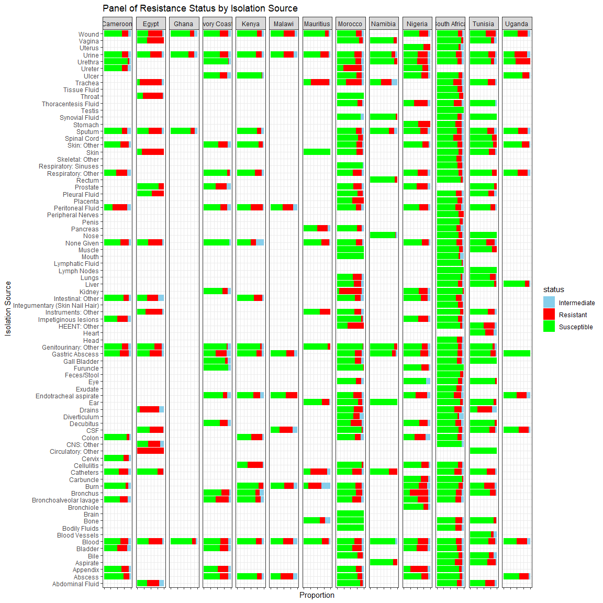

ggplot(df, aes(x = in_out_patient, fill = status)) +  
 geom_bar(position = "fill") +  
 labs(title = "Proportion of Resistance Status by Hospital Stay", x = "Hospital Stay", y = "Proportion") +  
 scale_fill_manual(values =c("Intermediate"="skyblue","Resistant"="red","Susceptible"="green")) +  
 theme_bw( ) +  
 coord_flip()

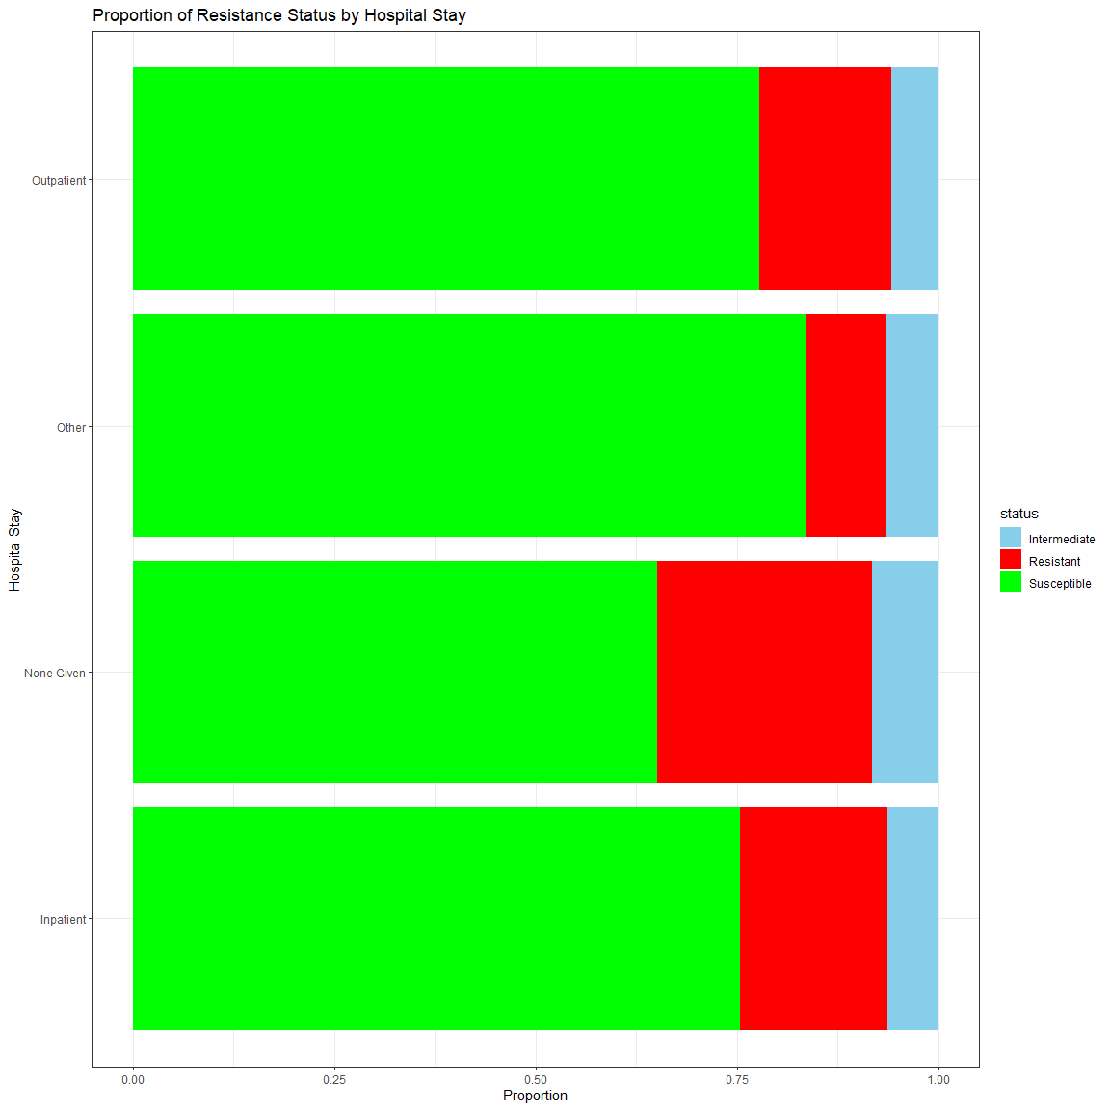

ggplot(df, aes(x = in_out_patient, fill = status)) +  
 geom_bar(position = "fill") +  
 facet_wrap( ~ country, scales = "free") +  
 labs(title = "Panel of Resistance Status by Hospital Stay", x = "Hospital Stay", y = "Proportion") +  
 scale_fill_manual(values =c("Intermediate"="skyblue","Resistant"="red","Susceptible"="green")) +  
 theme_bw( ) +  
 #theme(axis.text.x = element_blank()) +  
 coord_flip()

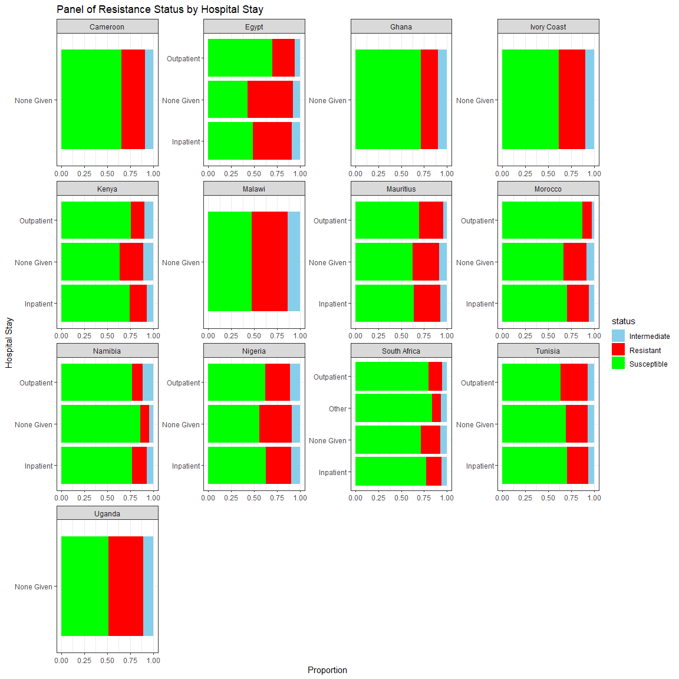

ggplot(df, aes(x = age_group, fill = status)) +  
 geom_bar(position = "fill") +  
 labs(title = "Proportion of Resistance Status by Age Group", x = "Age Group", y = "Proportion") +  
 scale_fill_manual(values =c("Intermediate"="skyblue","Resistant"="red","Susceptible"="green")) +  
 theme_bw( ) +  
 coord_flip()

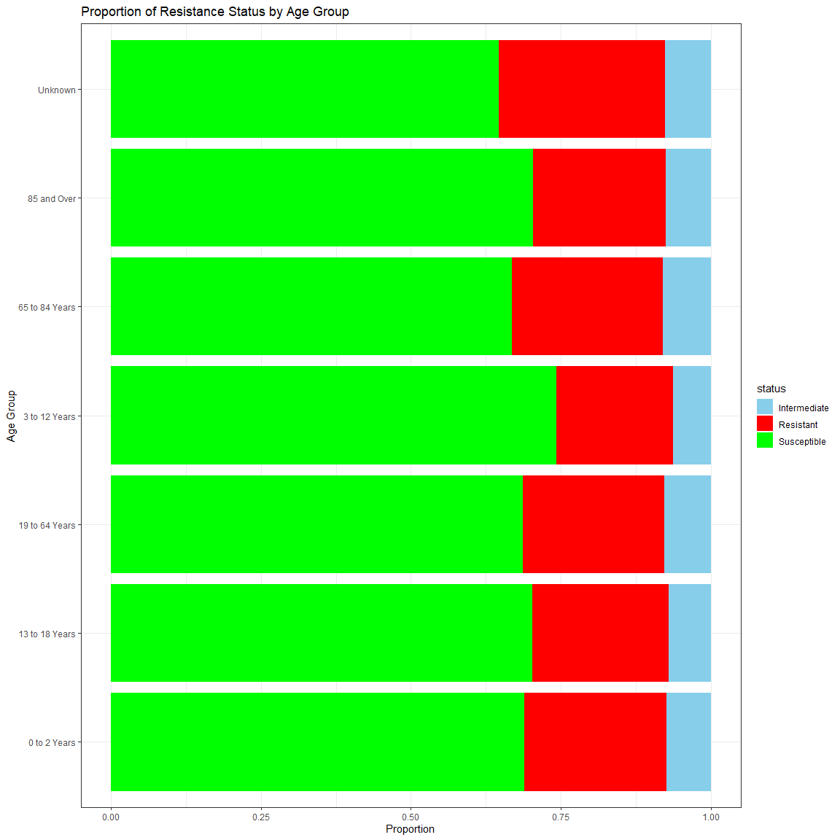

ggplot(df, aes(x = age_group, fill = status)) +  
 geom_bar(position = "fill") +  
 facet_wrap( ~ country, scales = "free") +  
 labs(title = "Panel of Resistance Status by Age Group", x = "Age Group", y = "Proportion") +  
 scale_fill_manual(values =c("Intermediate"="skyblue","Resistant"="red","Susceptible"="green")) +  
 theme_bw( ) +  
 #theme(axis.text.x = element_blank()) +  
 coord_flip()

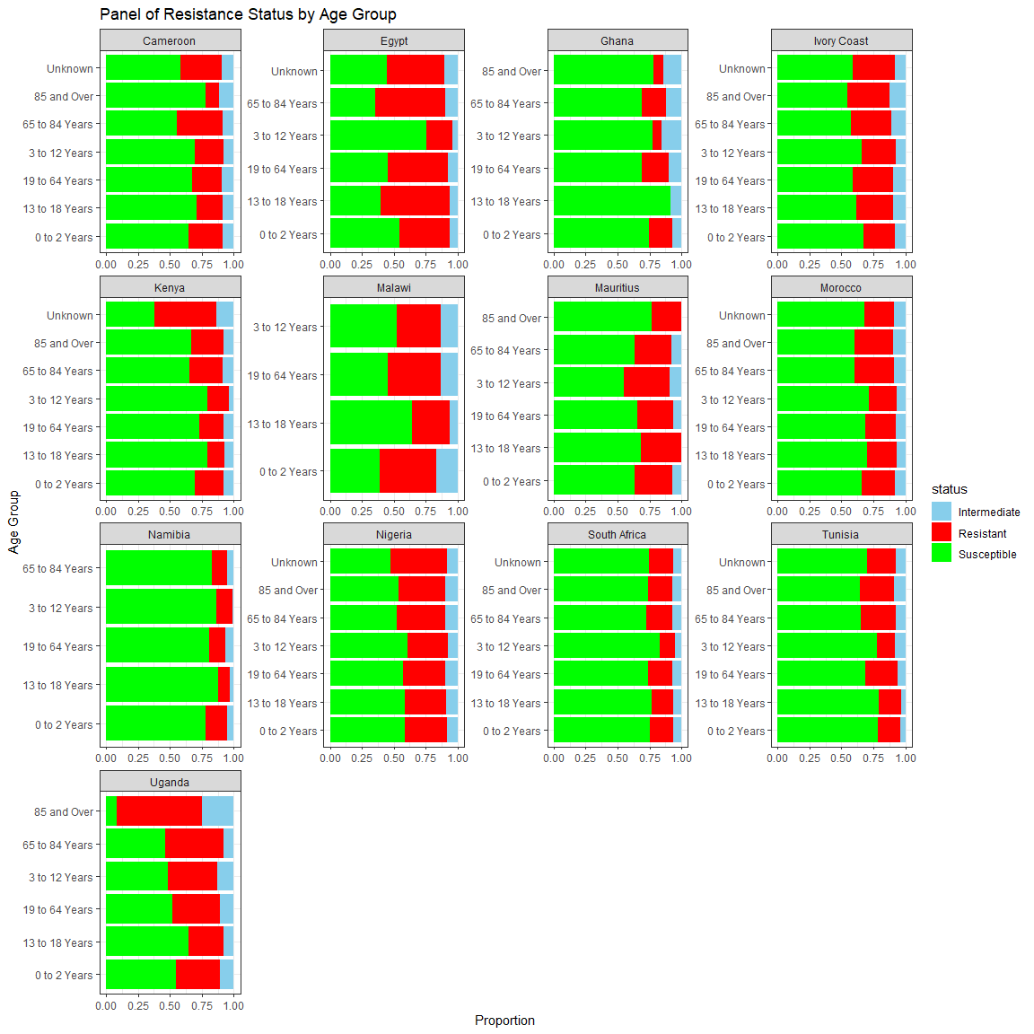

ggplot(df, aes(x = family, fill = status)) +  
 geom_bar(position = "fill") +  
 labs(title = "Proportion of Resistance Status by Family", x = "Family", y = "Proportion") +  
 scale_fill_manual(values =c("Intermediate"="skyblue","Resistant"="red","Susceptible"="green")) +  
 theme_bw( ) +  
 coord_flip()

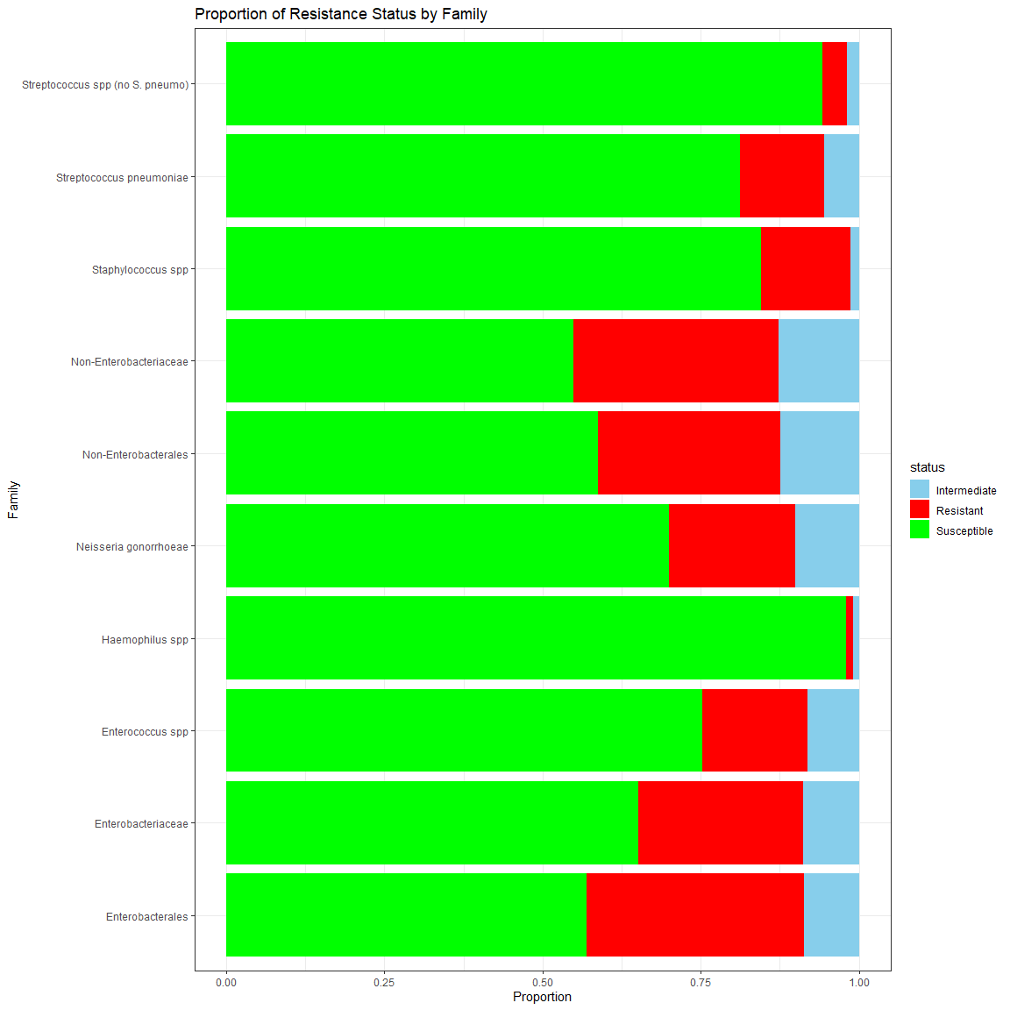

ggplot(df, aes(x = family, fill = status)) +  
 geom_bar(position = "fill") +  
 facet_wrap( ~ country, scales = "free") +  
 labs(title = "Panel of Resistance Status by family", x = "Family", y = "Proportion") +  
 scale_fill_manual(values =c("Intermediate"="skyblue","Resistant"="red","Susceptible"="green")) +  
 theme_bw( ) +  
 #theme(axis.text.x = element_blank()) +  
 coord_flip()

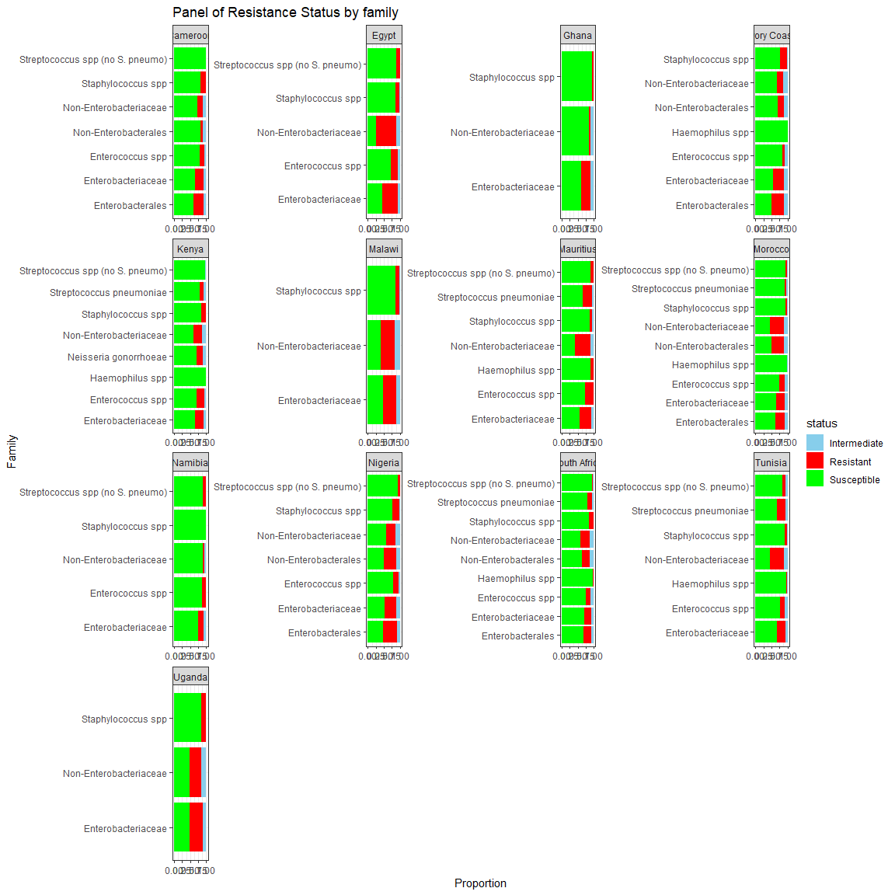

# Summarize MIC and Status by Country

# Simple ANOVA for MIC by country, controlling for antibiotics, species, and age

model <- lm(concentration ~ country + antibiotics + species, data = df)  
summary(model)

##   
## Call:  
## lm(formula = concentration ~ country + antibiotics + species,   
## data = df)  
##   
## Residuals:  
## Min 1Q Median 3Q Max   
## -43.972 -6.072 -1.139 2.234 128.262   
##   
## Coefficients:  
## Estimate Std. Error t value  
## (Intercept) 23.0460 0.2298 100.302  
## countryEgypt 8.4843 0.3229 26.278  
## countryGhana 0.5774 0.4577 1.262  
## countryIvory Coast 1.0250 0.2246 4.564  
## countryKenya 2.8741 0.2180 13.181  
## countryMalawi 2.3169 0.5188 4.465  
## countryMauritius 6.2348 0.5082 12.269  
## countryMorocco 1.4179 0.1643 8.631  
## countryNamibia -0.4630 0.4832 -0.958  
## countryNigeria 3.8924 0.1628 23.906  
## countrySouth Africa 1.0984 0.1568 7.003  
## countryTunisia 2.0308 0.2415 8.409  
## countryUganda 3.3872 0.3701 9.151  
## antibioticsAmoxycillin clavulanate 4.8779 0.1821 26.786  
## antibioticsAmpicillin 11.4132 0.1794 63.631  
## antibioticsAmpicillin sulbactam 10.8332 0.2176 49.794  
## antibioticsAzithromycin 12.5947 0.7108 17.718  
## antibioticsAztreonam 11.7271 0.1889 62.083  
## antibioticsCefepime 0.3798 0.1680 2.261  
## antibioticsCefixime 22.5371 0.4762 47.324  
## antibioticsCefpodoxime 0.9728 0.4765 2.041  
## antibioticsCeftaroline 2.7975 0.1838 15.223  
## antibioticsCeftazidime 9.3193 0.1710 54.512  
## antibioticsCeftazidime avibactam -2.9111 0.1892 -15.390  
## antibioticsCeftibuten 5.6193 0.4765 11.792  
## antibioticsCeftolozane tazobactam -5.0680 0.2326 -21.791  
## antibioticsCeftriaxone 2.0874 0.2241 9.313  
## antibioticsCiprofloxacin -7.8240 0.2028 -38.584  
## antibioticsClarithromycin 14.5097 0.8326 17.427  
## antibioticsClindamycin -1.4677 0.2529 -5.803  
## antibioticsColistin -7.9091 0.1869 -42.307  
## antibioticsDaptomycin -2.2043 0.2598 -8.483  
## antibioticsDoripenem -6.3539 0.2667 -23.828  
## antibioticsErtapenem -6.1379 0.5253 -11.685  
## antibioticsErythromycin -0.1712 0.2417 -0.708  
## antibioticsGentamicin -1.0458 0.1948 -5.369  
## antibioticsImipenem -7.0538 0.1796 -39.265  
## antibioticsLevofloxacin -4.4923 0.1565 -28.696  
## antibioticsLinezolid -1.3545 0.2263 -5.986  
## antibioticsMeropenem -6.3286 0.1653 -38.275  
## antibioticsMeropenem vaborbactam -6.7971 0.2716 -25.030  
## antibioticsMinocycline -2.5209 0.2181 -11.559  
## antibioticsMoxifloxacin -1.7013 0.3728 -4.563  
## antibioticsOxacillin -1.4877 0.2825 -5.266  
## antibioticsPenicillin -1.7188 0.3567 -4.818  
## antibioticsPiperacillin tazobactam 13.4420 0.1675 80.243  
## antibioticsQuinupristin dalfopristin 1.7726 1.5072 1.176  
## antibioticsTeicoplanin -1.7127 0.2646 -6.473  
## antibioticsTetracycline 8.6415 11.9698 0.722  
## antibioticsTigecycline -4.9790 0.1662 -29.958  
## antibioticsTrimethoprim sulfa 5.4835 0.1947 28.160  
## antibioticsVancomycin -1.9132 0.2263 -8.455  
## speciesAcinetobacter baylyi -22.1763 2.0095 -11.036  
## speciesAcinetobacter bereziniae -17.2686 1.1003 -15.694  
## speciesAcinetobacter calcoaceticus -21.5764 1.9589 -11.015  
## speciesAcinetobacter colistiniresistens -25.4747 4.3726 -5.826  
## speciesAcinetobacter courvalinii -4.5419 4.3851 -1.036  
## speciesAcinetobacter dijkshoorniae -19.5233 1.1357 -17.190  
## speciesAcinetobacter guillouiae -25.2275 2.5268 -9.984  
## speciesAcinetobacter haemolyticus -17.4585 1.0789 -16.181  
## speciesAcinetobacter johnsonii -20.9938 3.0931 -6.787  
## speciesAcinetobacter junii -18.1874 1.6191 -11.233  
## speciesAcinetobacter lactucae -14.7560 3.0938 -4.769  
## speciesAcinetobacter lwoffii -19.7021 1.5506 -12.706  
## speciesAcinetobacter nosocomialis -18.5416 0.5160 -35.931  
## speciesAcinetobacter parvus -25.0527 5.3541 -4.679  
## speciesAcinetobacter pitii -18.2206 0.9495 -19.190  
## speciesAcinetobacter proteolyticus -19.0556 4.3722 -4.358  
## speciesAcinetobacter radioresistens -25.4876 1.5198 -16.771  
## speciesAcinetobacter schindleri -20.9170 2.2865 -9.148  
## speciesAcinetobacter seifertii -21.1702 1.9599 -10.802  
## speciesAcinetobacter soli -22.6943 3.0938 -7.335  
## speciesAcinetobacter spp -4.8536 0.4454 -10.896  
## speciesAcinetobacter ursingii -13.5933 1.3658 -9.952  
## speciesAcinetobacter variabilis -6.3080 4.3726 -1.443  
## speciesAcinetobacter, non-speciated -1.6623 1.1615 -1.431  
## speciesAeromonas hydrophila -25.7160 4.7896 -5.369  
## speciesAeromonas veronii -21.6393 5.3542 -4.042  
## speciesAlcaligenes faecalis -17.7800 4.7896 -3.712  
## speciesBordetella trematum -16.5240 4.7896 -3.450  
## speciesBurkholderia cenocepacia -24.4339 7.5710 -3.227  
## speciesCitrobacter amalonaticus -20.4277 1.1859 -17.225  
## speciesCitrobacter braakii -18.5289 1.0291 -18.005  
## speciesCitrobacter freundii -17.5144 0.3184 -55.007  
## speciesCitrobacter koseri -22.9718 0.3405 -67.473  
## speciesCitrobacter sedlakii -14.9910 1.4764 -10.153  
## speciesCitrobacter spp -17.3332 1.1094 -15.623  
## speciesEnterobacter agglomerans -15.1273 1.4877 -10.168  
## speciesEnterobacter asburiae -19.3043 0.4629 -41.706  
## speciesEnterobacter bugandensis -21.6706 0.5186 -41.785  
## speciesEnterobacter cloacae -15.4512 0.1773 -87.146  
## speciesEnterobacter hormaechi -15.8231 0.4906 -32.254  
## speciesEnterobacter kobei -21.0807 0.7989 -26.387  
## speciesEnterobacter ludwigii -20.9544 2.8144 -7.446  
## speciesEnterobacter roggenkampii -18.2260 1.3007 -14.012  
## speciesEnterobacter sakazakii -24.8184 3.3093 -7.500  
## speciesEnterobacter spp -18.7356 0.2935 -63.838  
## speciesEnterobacter xiangfangensis -19.3290 0.7855 -24.607  
## speciesEnterobacter, non-speciated -19.2142 0.9223 -20.833  
## speciesEnterococcus avium -22.3670 2.8655 -7.806  
## speciesEnterococcus canintestini -22.1789 5.3548 -4.142  
## speciesEnterococcus casseliflavus -17.7710 3.6760 -4.834  
## speciesEnterococcus durans -21.9666 4.0513 -5.422  
## speciesEnterococcus faecalis -21.6442 0.2308 -93.768  
## speciesEnterococcus faecium -19.6961 0.3352 -58.752  
## speciesEnterococcus gallinarum -17.7381 3.6760 -4.825  
## speciesEnterococcus hirae -22.8446 3.1608 -7.227  
## speciesEnterococcus raffinosus -22.0437 3.9120 -5.635  
## speciesEnterococcus spp -23.2853 2.0293 -11.475  
## speciesEnterococcus, non-speciated -20.4125 2.5638 -7.962  
## speciesEscherichia coli -18.9543 0.1440 -131.593  
## speciesEscherichia hermanii -22.6390 3.9112 -5.788  
## speciesHaemophilus influenzae -26.3441 0.2324 -113.369  
## speciesHaemophilus parainfluenzae -25.9611 1.2084 -21.484  
## speciesKlebsiella aerogenes -18.8924 0.2880 -65.600  
## speciesKlebsiella oxytoca -21.4952 0.2628 -81.782  
## speciesKlebsiella ozaenae -22.2825 3.3134 -6.725  
## speciesKlebsiella planticola 10.9944 4.5666 2.408  
## speciesKlebsiella pneumoniae -13.5203 0.1445 -93.534  
## speciesKlebsiella spp -14.0563 0.9634 -14.590  
## speciesKlebsiella variicola -22.5366 0.3896 -57.851  
## speciesLelliottia amnigena -7.8234 4.7893 -1.634  
## speciesMorganella morganii -20.0955 0.2777 -72.375  
## speciesMyroides odoratimimus 2.5950 4.7896 0.542  
## speciesNeisseria gonorrhoeae -32.3115 5.3579 -6.031  
## speciesPantoea dispersa -5.2190 3.5712 -1.461  
## speciesPluralibacter gergoviae -22.7515 1.7770 -12.803  
## speciesProteus hauseri -22.0972 0.9702 -22.776  
## speciesProteus mirabilis -21.8063 0.2157 -101.100  
## speciesProteus penneri -22.0564 1.9273 -11.444  
## speciesProteus spp -21.6010 1.1268 -19.170  
## speciesProteus vulgaris -21.8592 0.4116 -53.107  
## speciesProvidencia alcalifaciens -23.3081 2.3126 -10.079  
## speciesProvidencia rettgeri -18.7763 0.4892 -38.380  
## speciesProvidencia spp -18.3394 1.2914 -14.201  
## speciesProvidencia stuartii -17.3978 0.4240 -41.030  
## speciesPseudomonas aeruginosa -16.5035 0.1555 -106.148  
## speciesPseudomonas fulva -7.5020 3.3879 -2.214  
## speciesPseudomonas putida -19.1349 1.9924 -9.604  
## speciesPseudomonas putida/fluorescens Group -20.0359 4.7892 -4.184  
## speciesPseudomonas spp -21.1779 1.6980 -12.472  
## speciesRaoultella ornithinolytica -24.8007 2.1036 -11.790  
## speciesSalmonella spp -22.3859 3.5715 -6.268  
## speciesSerratia liquefaciens -20.0950 1.4699 -13.671  
## speciesSerratia marcescens -19.6864 0.2138 -92.088  
## speciesSerratia rubidaea -23.3034 3.2308 -7.213  
## speciesSerratia spp -21.1198 0.7648 -27.613  
## speciesSerratia ureilytica -21.2764 2.5270 -8.420  
## speciesSerratia, non-speciated -20.0856 4.5668 -4.398  
## speciesStaphylococcus arlettae -24.3167 3.2320 -7.524  
## speciesStaphylococcus aureus -22.1234 0.1687 -131.141  
## speciesStaphylococcus capitis -21.0791 1.3031 -16.176  
## speciesStaphylococcus caprae -25.1417 4.5677 -5.504  
## speciesStaphylococcus Coagulase Negative -21.8296 0.6048 -36.092  
## speciesStaphylococcus cohnii -22.3500 1.5151 -14.752  
## speciesStaphylococcus condimenti -22.3421 4.5673 -4.892  
## speciesStaphylococcus epidermidis -21.4742 0.2660 -80.725  
## speciesStaphylococcus haemolyticus -21.9086 0.2559 -85.620  
## speciesStaphylococcus hominis -22.8351 0.6558 -34.821  
## speciesStaphylococcus lugdunensis -22.2225 1.3321 -16.683  
## speciesStaphylococcus pasteuri -22.0470 3.0941 -7.125  
## speciesStaphylococcus pettenkoferi -21.4921 4.5675 -4.705  
## speciesStaphylococcus pseudointermedius -22.1839 4.2018 -5.280  
## speciesStaphylococcus saccharolyticus -24.2257 3.2320 -7.496  
## speciesStaphylococcus saprophyticus -23.2650 1.1789 -19.734  
## speciesStaphylococcus sciuri -23.5536 1.0913 -21.582  
## speciesStaphylococcus simulans -22.8053 2.6402 -8.638  
## speciesStaphylococcus spp -21.4560 0.7789 -27.547  
## speciesStaphylococcus warneri -21.5794 1.2805 -16.852  
## speciesStaphylococcus xylosus -23.9878 1.9456 -12.329  
## speciesStenotrophomonas maltophilia -23.4996 2.3708 -9.912  
## speciesStreptococcus agalactiae -22.2462 0.2573 -86.447  
## speciesStreptococcus anginosus -21.2587 0.9809 -21.673  
## speciesStreptococcus constellatus -21.1982 1.6491 -12.854  
## speciesStreptococcus dysgalactiae -21.8628 0.7084 -30.863  
## speciesStreptococcus gallolyticus -21.0883 2.1904 -9.628  
## speciesStreptococcus oralis -19.3956 4.2017 -4.616  
## speciesStreptococcus parasanguinis -20.8440 4.2017 -4.961  
## speciesStreptococcus pneumoniae -20.8863 0.2086 -100.104  
## speciesStreptococcus pyogenes -22.0116 0.3131 -70.304  
## speciesStreptococcus salivarius -20.5506 2.9730 -6.912  
## speciesStreptococcus, Beta Hemolytic -22.1145 2.7682 -7.989  
## Pr(>|t|)   
## (Intercept) < 2e-16 ***  
## countryEgypt < 2e-16 ***  
## countryGhana 0.207033   
## countryIvory Coast 5.03e-06 ***  
## countryKenya < 2e-16 ***  
## countryMalawi 8.00e-06 ***  
## countryMauritius < 2e-16 ***  
## countryMorocco < 2e-16 ***  
## countryNamibia 0.337962   
## countryNigeria < 2e-16 ***  
## countrySouth Africa 2.51e-12 ***  
## countryTunisia < 2e-16 ***  
## countryUganda < 2e-16 ***  
## antibioticsAmoxycillin clavulanate < 2e-16 ***  
## antibioticsAmpicillin < 2e-16 ***  
## antibioticsAmpicillin sulbactam < 2e-16 ***  
## antibioticsAzithromycin < 2e-16 ***  
## antibioticsAztreonam < 2e-16 ***  
## antibioticsCefepime 0.023744 *   
## antibioticsCefixime < 2e-16 ***  
## antibioticsCefpodoxime 0.041213 *   
## antibioticsCeftaroline < 2e-16 ***  
## antibioticsCeftazidime < 2e-16 ***  
## antibioticsCeftazidime avibactam < 2e-16 ***  
## antibioticsCeftibuten < 2e-16 ***  
## antibioticsCeftolozane tazobactam < 2e-16 ***  
## antibioticsCeftriaxone < 2e-16 ***  
## antibioticsCiprofloxacin < 2e-16 ***  
## antibioticsClarithromycin < 2e-16 ***  
## antibioticsClindamycin 6.50e-09 ***  
## antibioticsColistin < 2e-16 ***  
## antibioticsDaptomycin < 2e-16 ***  
## antibioticsDoripenem < 2e-16 ***  
## antibioticsErtapenem < 2e-16 ***  
## antibioticsErythromycin 0.478691   
## antibioticsGentamicin 7.93e-08 ***  
## antibioticsImipenem < 2e-16 ***  
## antibioticsLevofloxacin < 2e-16 ***  
## antibioticsLinezolid 2.15e-09 ***  
## antibioticsMeropenem < 2e-16 ***  
## antibioticsMeropenem vaborbactam < 2e-16 ***  
## antibioticsMinocycline < 2e-16 ***  
## antibioticsMoxifloxacin 5.04e-06 ***  
## antibioticsOxacillin 1.39e-07 ***  
## antibioticsPenicillin 1.45e-06 ***  
## antibioticsPiperacillin tazobactam < 2e-16 ***  
## antibioticsQuinupristin dalfopristin 0.239567   
## antibioticsTeicoplanin 9.64e-11 ***  
## antibioticsTetracycline 0.470333   
## antibioticsTigecycline < 2e-16 ***  
## antibioticsTrimethoprim sulfa < 2e-16 ***  
## antibioticsVancomycin < 2e-16 ***  
## speciesAcinetobacter baylyi < 2e-16 ***  
## speciesAcinetobacter bereziniae < 2e-16 ***  
## speciesAcinetobacter calcoaceticus < 2e-16 ***  
## speciesAcinetobacter colistiniresistens 5.68e-09 ***  
## speciesAcinetobacter courvalinii 0.300307   
## speciesAcinetobacter dijkshoorniae < 2e-16 ***  
## speciesAcinetobacter guillouiae < 2e-16 ***  
## speciesAcinetobacter haemolyticus < 2e-16 ***  
## speciesAcinetobacter johnsonii 1.14e-11 ***  
## speciesAcinetobacter junii < 2e-16 ***  
## speciesAcinetobacter lactucae 1.85e-06 ***  
## speciesAcinetobacter lwoffii < 2e-16 ***  
## speciesAcinetobacter nosocomialis < 2e-16 ***  
## speciesAcinetobacter parvus 2.88e-06 ***  
## speciesAcinetobacter pitii < 2e-16 ***  
## speciesAcinetobacter proteolyticus 1.31e-05 ***  
## speciesAcinetobacter radioresistens < 2e-16 ***  
## speciesAcinetobacter schindleri < 2e-16 ***  
## speciesAcinetobacter seifertii < 2e-16 ***  
## speciesAcinetobacter soli 2.22e-13 ***  
## speciesAcinetobacter spp < 2e-16 ***  
## speciesAcinetobacter ursingii < 2e-16 ***  
## speciesAcinetobacter variabilis 0.149130   
## speciesAcinetobacter, non-speciated 0.152399   
## speciesAeromonas hydrophila 7.92e-08 ***  
## speciesAeromonas veronii 5.31e-05 ***  
## speciesAlcaligenes faecalis 0.000205 ***  
## speciesBordetella trematum 0.000561 ***  
## speciesBurkholderia cenocepacia 0.001250 **   
## speciesCitrobacter amalonaticus < 2e-16 ***  
## speciesCitrobacter braakii < 2e-16 ***  
## speciesCitrobacter freundii < 2e-16 ***  
## speciesCitrobacter koseri < 2e-16 ***  
## speciesCitrobacter sedlakii < 2e-16 ***  
## speciesCitrobacter spp < 2e-16 ***  
## speciesEnterobacter agglomerans < 2e-16 ***  
## speciesEnterobacter asburiae < 2e-16 ***  
## speciesEnterobacter bugandensis < 2e-16 ***  
## speciesEnterobacter cloacae < 2e-16 ***  
## speciesEnterobacter hormaechi < 2e-16 ***  
## speciesEnterobacter kobei < 2e-16 ***  
## speciesEnterobacter ludwigii 9.68e-14 ***  
## speciesEnterobacter roggenkampii < 2e-16 ***  
## speciesEnterobacter sakazakii 6.42e-14 ***  
## speciesEnterobacter spp < 2e-16 ***  
## speciesEnterobacter xiangfangensis < 2e-16 ***  
## speciesEnterobacter, non-speciated < 2e-16 ***  
## speciesEnterococcus avium 5.94e-15 ***  
## speciesEnterococcus canintestini 3.45e-05 ***  
## speciesEnterococcus casseliflavus 1.34e-06 ***  
## speciesEnterococcus durans 5.89e-08 ***  
## speciesEnterococcus faecalis < 2e-16 ***  
## speciesEnterococcus faecium < 2e-16 ***  
## speciesEnterococcus gallinarum 1.40e-06 ***  
## speciesEnterococcus hirae 4.93e-13 ***  
## speciesEnterococcus raffinosus 1.75e-08 ***  
## speciesEnterococcus spp < 2e-16 ***  
## speciesEnterococcus, non-speciated 1.70e-15 ***  
## speciesEscherichia coli < 2e-16 ***  
## speciesEscherichia hermanii 7.12e-09 ***  
## speciesHaemophilus influenzae < 2e-16 ***  
## speciesHaemophilus parainfluenzae < 2e-16 ***  
## speciesKlebsiella aerogenes < 2e-16 ***  
## speciesKlebsiella oxytoca < 2e-16 ***  
## speciesKlebsiella ozaenae 1.76e-11 ***  
## speciesKlebsiella planticola 0.016060 *   
## speciesKlebsiella pneumoniae < 2e-16 ***  
## speciesKlebsiella spp < 2e-16 ***  
## speciesKlebsiella variicola < 2e-16 ***  
## speciesLelliottia amnigena 0.102364   
## speciesMorganella morganii < 2e-16 ***  
## speciesMyroides odoratimimus 0.587955   
## speciesNeisseria gonorrhoeae 1.64e-09 ***  
## speciesPantoea dispersa 0.143906   
## speciesPluralibacter gergoviae < 2e-16 ***  
## speciesProteus hauseri < 2e-16 ***  
## speciesProteus mirabilis < 2e-16 ***  
## speciesProteus penneri < 2e-16 ***  
## speciesProteus spp < 2e-16 ***  
## speciesProteus vulgaris < 2e-16 ***  
## speciesProvidencia alcalifaciens < 2e-16 ***  
## speciesProvidencia rettgeri < 2e-16 ***  
## speciesProvidencia spp < 2e-16 ***  
## speciesProvidencia stuartii < 2e-16 ***  
## speciesPseudomonas aeruginosa < 2e-16 ***  
## speciesPseudomonas fulva 0.026804 *   
## speciesPseudomonas putida < 2e-16 ***  
## speciesPseudomonas putida/fluorescens Group 2.87e-05 ***  
## speciesPseudomonas spp < 2e-16 ***  
## speciesRaoultella ornithinolytica < 2e-16 ***  
## speciesSalmonella spp 3.66e-10 ***  
## speciesSerratia liquefaciens < 2e-16 ***  
## speciesSerratia marcescens < 2e-16 ***  
## speciesSerratia rubidaea 5.49e-13 ***  
## speciesSerratia spp < 2e-16 ***  
## speciesSerratia ureilytica < 2e-16 ***  
## speciesSerratia, non-speciated 1.09e-05 ***  
## speciesStaphylococcus arlettae 5.34e-14 ***  
## speciesStaphylococcus aureus < 2e-16 ***  
## speciesStaphylococcus capitis < 2e-16 ***  
## speciesStaphylococcus caprae 3.71e-08 ***  
## speciesStaphylococcus Coagulase Negative < 2e-16 ***  
## speciesStaphylococcus cohnii < 2e-16 ***  
## speciesStaphylococcus condimenti 1.00e-06 ***  
## speciesStaphylococcus epidermidis < 2e-16 ***  
## speciesStaphylococcus haemolyticus < 2e-16 ***  
## speciesStaphylococcus hominis < 2e-16 ***  
## speciesStaphylococcus lugdunensis < 2e-16 ***  
## speciesStaphylococcus pasteuri 1.04e-12 ***  
## speciesStaphylococcus pettenkoferi 2.53e-06 ***  
## speciesStaphylococcus pseudointermedius 1.30e-07 ***  
## speciesStaphylococcus saccharolyticus 6.62e-14 ***  
## speciesStaphylococcus saprophyticus < 2e-16 ***  
## speciesStaphylococcus sciuri < 2e-16 ***  
## speciesStaphylococcus simulans < 2e-16 ***  
## speciesStaphylococcus spp < 2e-16 ***  
## speciesStaphylococcus warneri < 2e-16 ***  
## speciesStaphylococcus xylosus < 2e-16 ***  
## speciesStenotrophomonas maltophilia < 2e-16 ***  
## speciesStreptococcus agalactiae < 2e-16 ***  
## speciesStreptococcus anginosus < 2e-16 ***  
## speciesStreptococcus constellatus < 2e-16 ***  
## speciesStreptococcus dysgalactiae < 2e-16 ***  
## speciesStreptococcus gallolyticus < 2e-16 ***  
## speciesStreptococcus oralis 3.91e-06 ***  
## speciesStreptococcus parasanguinis 7.02e-07 ***  
## speciesStreptococcus pneumoniae < 2e-16 ***  
## speciesStreptococcus pyogenes < 2e-16 ***  
## speciesStreptococcus salivarius 4.78e-12 ***  
## speciesStreptococcus, Beta Hemolytic 1.37e-15 ***  
## ---  
## Signif. codes: 0 '***' 0.001 '**' 0.01 '*' 0.05 '.' 0.1 ' ' 1  
##   
## Residual standard error: 15.14 on 329918 degrees of freedom  
## Multiple R-squared: 0.2464, Adjusted R-squared: 0.246   
## F-statistic: 596.1 on 181 and 329918 DF, p-value: < 2.2e-16

anova(model)

## Analysis of Variance Table  
##   
## Response: concentration  
## Df Sum Sq Mean Sq F value Pr(>F)   
## country 12 1115380 92948 405.55 < 2.2e-16 ***  
## antibiotics 39 16635623 426554 1861.14 < 2.2e-16 ***  
## species 130 6978427 53680 234.22 < 2.2e-16 ***  
## Residuals 329918 75613750 229   
## ---  
## Signif. codes: 0 '***' 0.001 '**' 0.01 '*' 0.05 '.' 0.1 ' ' 1

## significance difference in resistance status between countries

status_table <- table(df$country, df$status)  
chisq_test <- chisq.test(status_table)  
print(status_table)

##   
## Intermediate Resistant Susceptible  
## Cameroon 923 2614 6806  
## Egypt 231 1363 1279  
## Ghana 125 225 883  
## Ivory Coast 769 2450 5123  
## Kenya 743 1927 6876  
## Malawi 126 365 441  
## Mauritius 66 282 635  
## Morocco 4374 14459 38320  
## Namibia 65 145 910  
## Nigeria 5428 20033 33098  
## South Africa 11560 32069 126573  
## Tunisia 452 1616 4720  
## Uganda 215 763 1048

print(chisq_test)

##   
## Pearson's Chi-squared test  
##   
## data: status_table  
## X-squared = 8782.4, df = 24, p-value < 2.2e-16